**Project Design Phase**

**Solution Architecture**

|  |  |
| --- | --- |
| Date | 15 February 2025 |
| Team ID | LTVIP2025TMID31213 |
| Project Name | EduTutor-AI- Personalized-Learning-withGenerative- AI-and-LMS-Integration |
| Maximum Marks | 4 Marks |

**Solution Architecture:**

**Solution architecture is a strategic approach that aligns business objectives with technical** implementation. For EduTutor-AI, the architecture is designed to:

* Identify the optimal technology stack to personalize education using generative AI.
* Present the structure and behavior of the solution to technical and non-technical stakeholders.
* Define functional modules, development phases, and integration points with LMS platforms.
* Provide specifications for scalable, secure, and efficient system delivery.

**Example - Solution Architecture Diagram:**

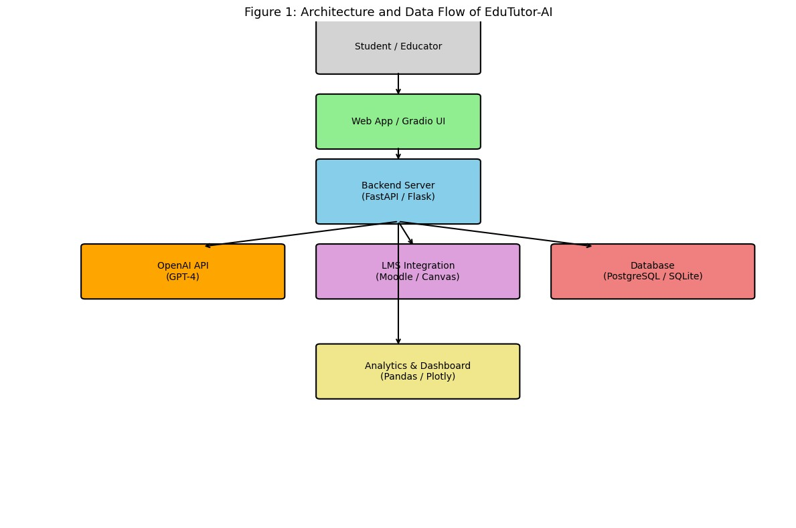

**Example:2**

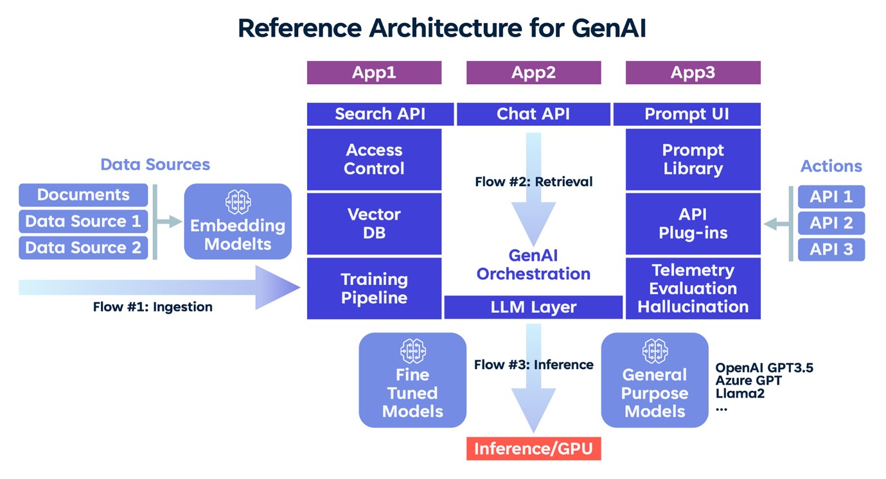

*Figure 1:*

**Reference:** https://edu tutor ai..com/blogs/industries/voice-applications-in EduTutor-AI-

Personalized-Learning-with-Generative- AI-and-LMS-Integration-clinical-research-powered-by-ai-onaws-part-1-architecture-and-design-considerations/